Institute of Computer Technology

B. Tech Computer Science and Engineering

Subject: Computer Organization (2CSE205)

**PRACTICAL-EXAM**

**AIM: - To study and design Combinational Multiplier.**

**Objective: - (i) Multiplication of two 4-bit numbers**

**(ii) Analyse Truth Table**

**Expected Input: Multiplier number**

**Expected Output: As order given of two 4-bit Number**

**Write one mathematical example also.**

***CIRCUIT DIAGRAM:***

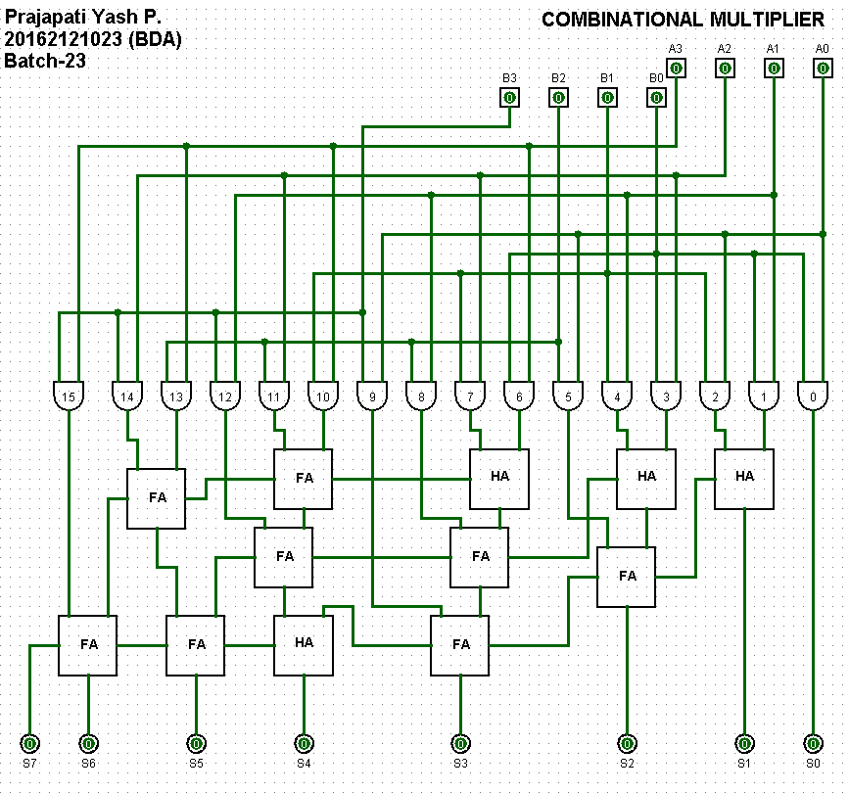

***TRUTH TABLE:***

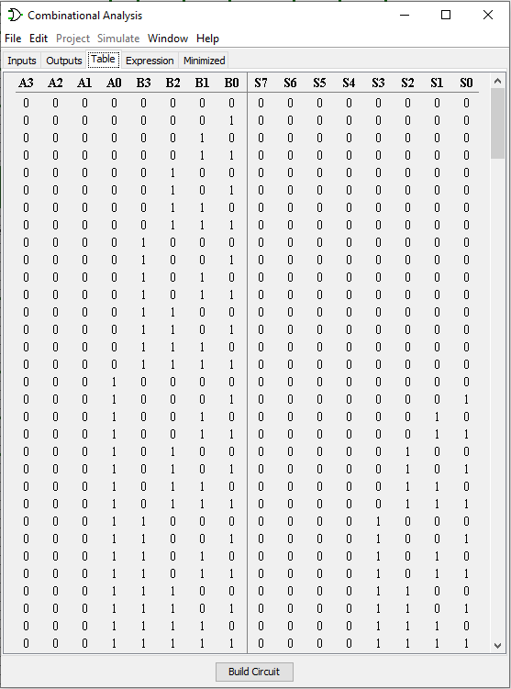

***MATHEMATICAL EXAMPLE:***

**For example 1**, Take multiplication of two numbers.

number 1 = 5 (0101)

number 2 = 2 (0010)

**5*2=10**

**0101 * 0010 = 1010**

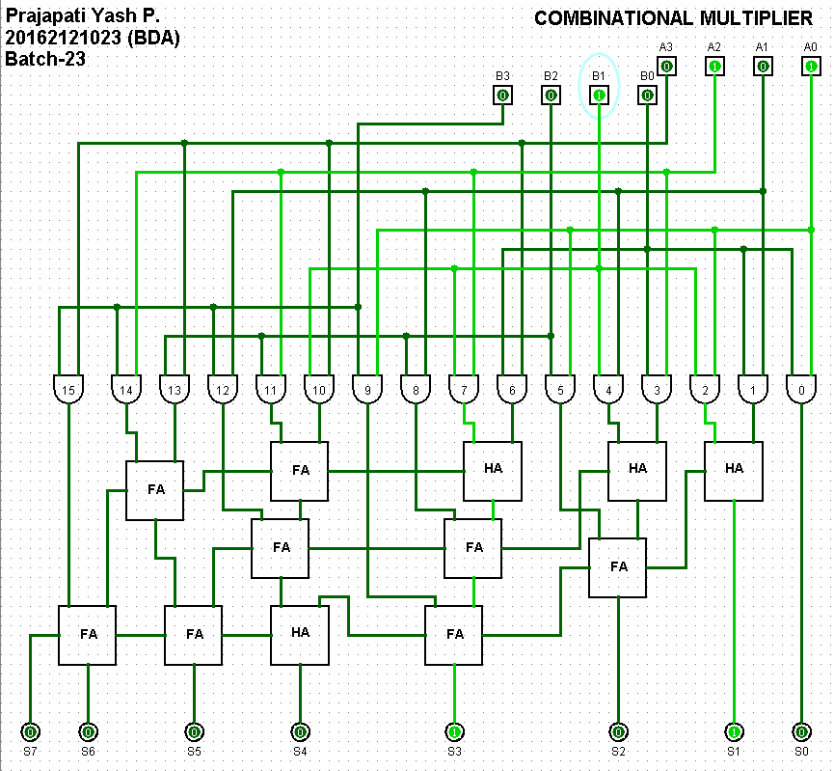

**For example 2**, Take multiplication of two numbers.

number 1 = 5 (0101)

number 2 = 11 (1011)

**5*11=55**

**0101 * 1011 = 00110111**

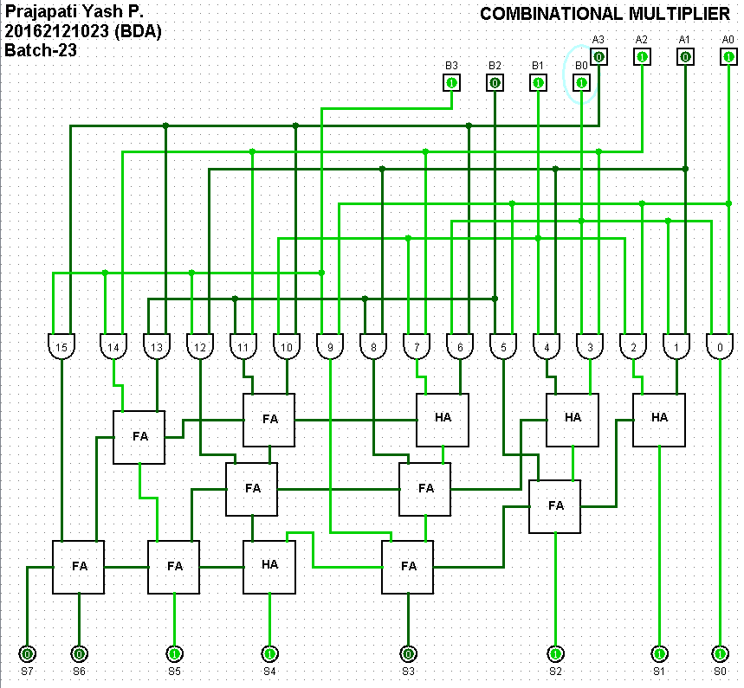

***CONCLUSION:***

Hence, by studying truth table and circuit diagram and analysing the example we conclude the study and design of Combinational Multiplier.